1.Implementing the Singleton Pattern
Logger.java
public class Logger {

private static Logger instance;

private Logger() {
System.out.println("Logger Initialized");
}

public static Logger getInstance() {
if (instance == null) {
instance = new Logger();
}
return instance;
}

public void log(String message) {
System.out.println("LOG: " + message);
}
}
SingletonTest.java
public class SingletonTest {

public static void main(String[] args) {

Logger logger1 = Logger.getInstance();
logger1.log("First Message");

Logger logger2 = Logger.getInstance();
logger2.log("Second Message");

// Checking if both references point to same object
if (logger1 == logger2) {
System.out.println("Only One Logger Instance Exists");
} else {
System.out.println("Multiple Instances Created");
}
}
}
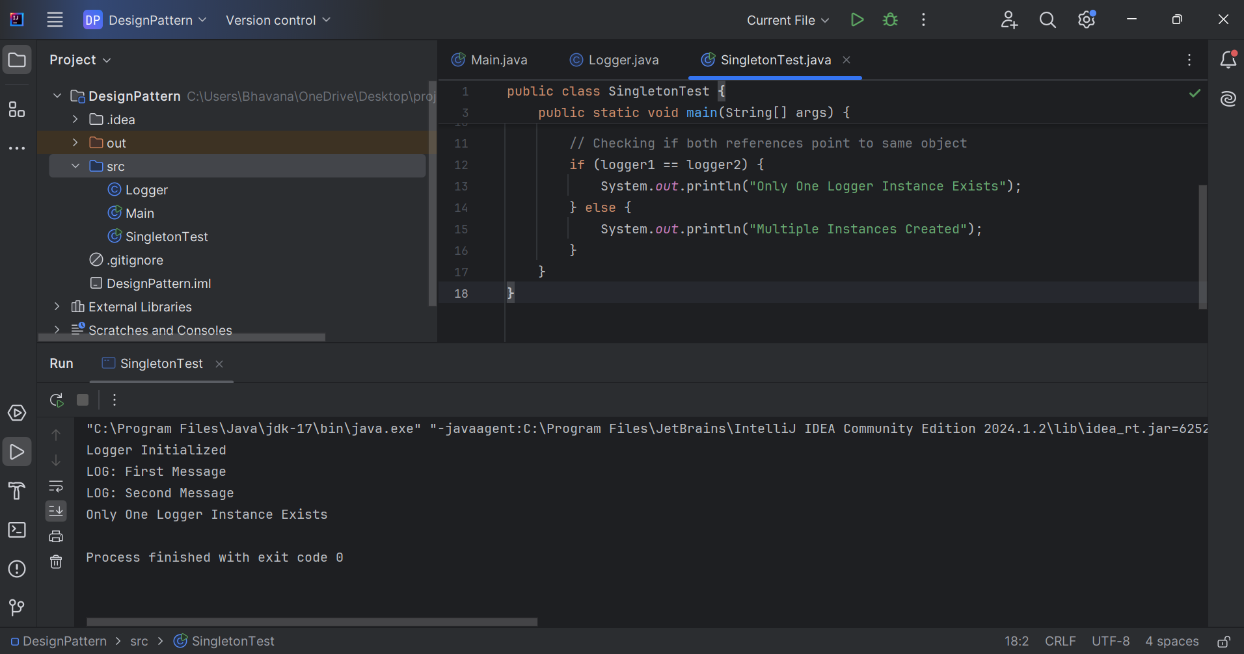
2.Implementing the Factory Method Pattern
Document.java
public interface Document {
void open();
}
WordDocument.java
public class WordDocument implements Document {

@Override
public void open() {
System.out.println("Opening Word Document");
}
}
PdfDocument.java
public class PdfDocument implements Document {

@Override
public void open() {
System.out.println("Opening PDF Document");
}
}
ExcelDocument.java
public class ExcelDocument implements Document {

@Override
public void open() {
System.out.println("Opening Excel Document");
}
}
DocumentFactory.java
public abstract class DocumentFactory {

public abstract Document createDocument();
}
WordFactory.java
public class WordFactory extends DocumentFactory {

@Override
public Document createDocument() {
return new WordDocument();
}
}
PdfFactory.java
public class PdfFactory extends DocumentFactory {

@Override
public Document createDocument() {
return new PdfDocument();
}
}
ExcelFactory.java
public class ExcelFactory extends DocumentFactory {

@Override
public Document createDocument() {
return new ExcelDocument();
}
}
FactoryTest.java
public class FactoryTest {

public static void main(String[] args) {

DocumentFactory wordFactory = new WordFactory();
Document wordDoc = wordFactory.createDocument();
wordDoc.open();

DocumentFactory pdfFactory = new PdfFactory();
Document pdfDoc = pdfFactory.createDocument();
pdfDoc.open();

DocumentFactory excelFactory = new ExcelFactory();
Document excelDoc = excelFactory.createDocument();
excelDoc.open();
}
}
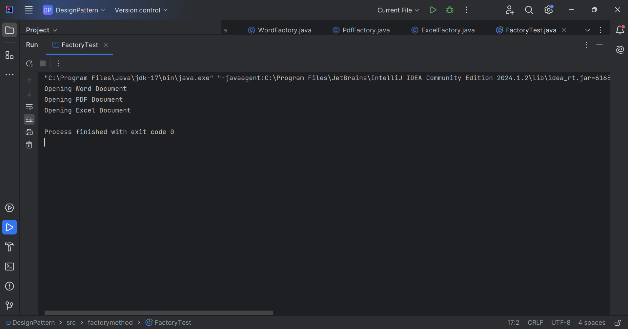
3.Implementing the Builder Pattern
Computer.java
public class Computer {

private String CPU;
private int RAM;
private int Storage;
private String GraphicsCard;

private Computer(Builder builder) {
this.CPU = builder.CPU;
this.RAM = builder.RAM;
this.Storage = builder.Storage;
this.GraphicsCard = builder.GraphicsCard;
}

public void showConfig() {
System.out.println("CPU: " + CPU);
System.out.println("RAM: " + RAM + " GB");
System.out.println("Storage: " + Storage + " GB");
System.out.println("Graphics Card: " + GraphicsCard);
System.out.println();
}

public static class Builder {

private String CPU;
private int RAM;
private int Storage;
private String GraphicsCard;

public Builder setCPU(String CPU) {
this.CPU = CPU;
return this;
}

public Builder setRAM(int RAM) {
this.RAM = RAM;
return this;
}

public Builder setStorage(int Storage) {
this.Storage = Storage;
return this;
}

public Builder setGraphicsCard(String GraphicsCard) {
this.GraphicsCard = GraphicsCard;
return this;
}

public Computer build() {
return new Computer(this);
}
}
}
BuilderTest.java
public class BuilderTest {

public static void main(String[] args) {

Computer gamingPC = new Computer.Builder()
.setCPU("Intel i9")
.setRAM(32)
.setStorage(1000)
.setGraphicsCard("NVIDIA RTX 4080")
.build();

Computer officePC = new Computer.Builder()
.setCPU("Intel i5")
.setRAM(8)
.setStorage(512)
.setGraphicsCard("Integrated Graphics")
.build();

System.out.println("Gaming PC Configuration:");
gamingPC.showConfig();

System.out.println("Office PC Configuration:");
officePC.showConfig();
}
}
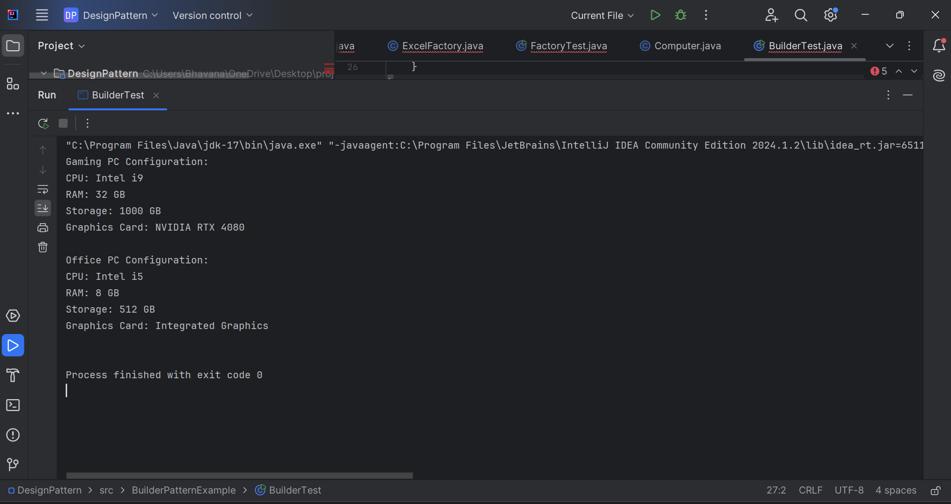
4. Implementing the Adapter Pattern
PaymentProcessor.java
public interface PaymentProcessor {
void processPayment(double amount);
}
PayPalGateway.java
public class PayPalGateway {

public void sendPayment(double amount) {
System.out.println("Payment of Rs." + amount + " processed through PayPal.");
}
}
StripeGateway.java
public class StripeGateway {

public void makePayment(double amount) {
System.out.println("Payment of Rs." + amount + " processed through Stripe.");
}
}
PayPalAdapter.java
public class PayPalAdapter implements PaymentProcessor {

private PayPalGateway payPalGateway;

public PayPalAdapter(PayPalGateway payPalGateway) {
this.payPalGateway = payPalGateway;
}

@Override
public void processPayment(double amount) {
payPalGateway.sendPayment(amount);
}
}
StripeAdapter.java
public class StripeAdapter implements PaymentProcessor {

private StripeGateway stripeGateway;

public StripeAdapter(StripeGateway stripeGateway) {
this.stripeGateway = stripeGateway;
}

@Override
public void processPayment(double amount) {
stripeGateway.makePayment(amount);
}
}
AdapterTest.java
public class AdapterTest {

public static void main(String[] args) {

PaymentProcessor payPal =
new PayPalAdapter(new PayPalGateway());

PaymentProcessor stripe =
new StripeAdapter(new StripeGateway());

payPal.processPayment(5000);
stripe.processPayment(10000);
}
}
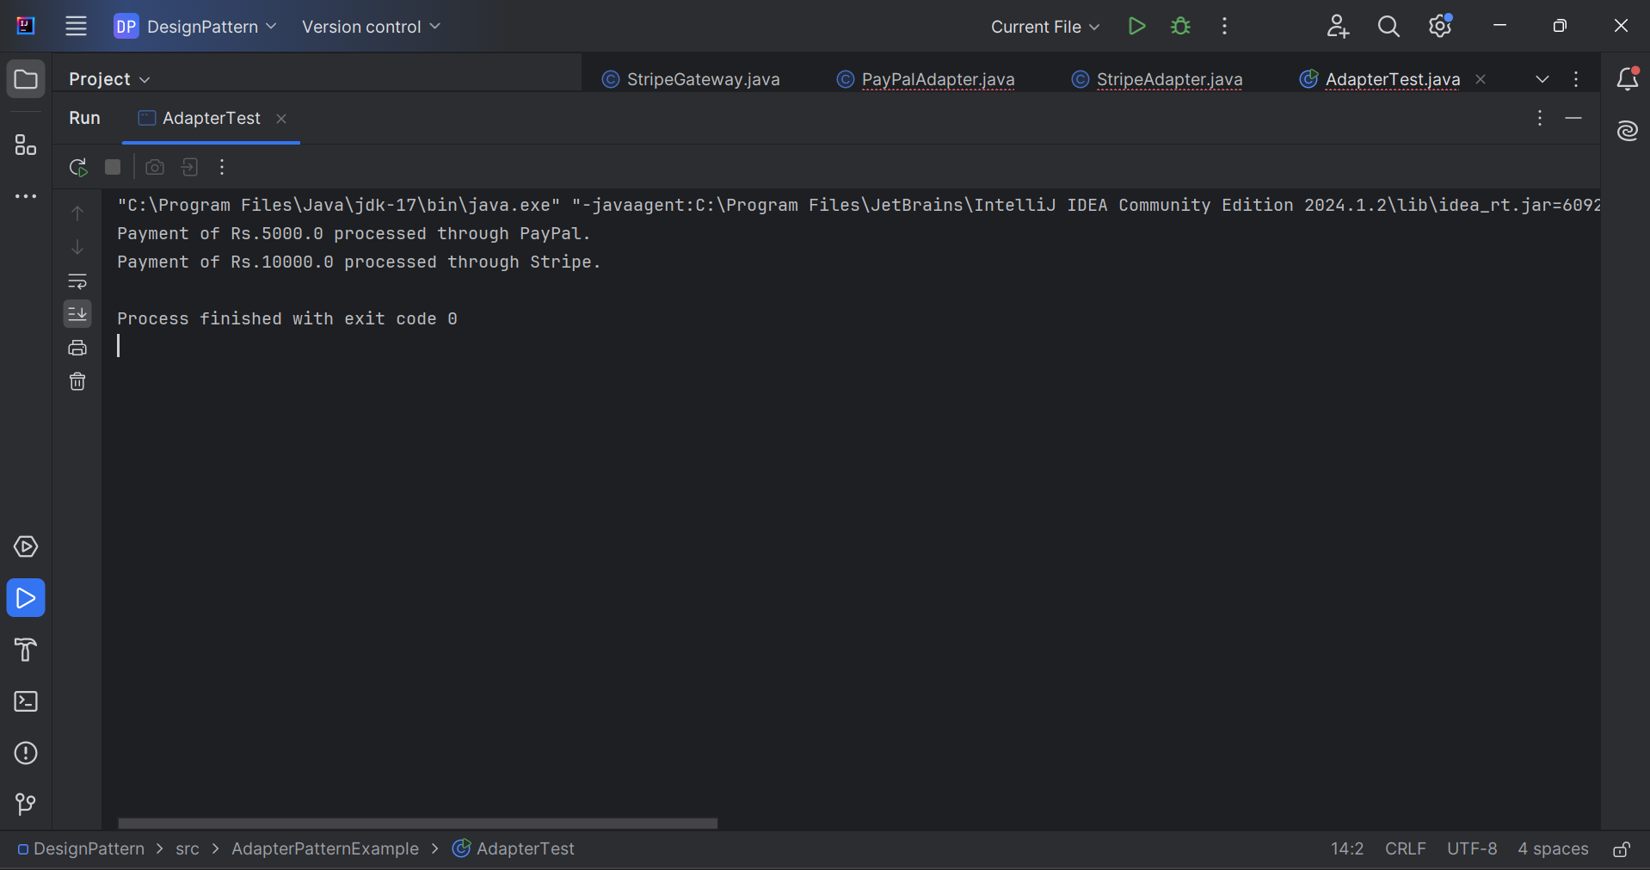

5.Implementing the Decorator Pattern
Notifier.java
public interface Notifier {
void send(String message);
}
EmailNotifier.java
public class EmailNotifier implements Notifier {

@Override
public void send(String message) {
System.out.println("Email Notification: " + message);
}
}
NotifierDecorator.java
public abstract class NotifierDecorator implements Notifier {

protected Notifier notifier;

public NotifierDecorator(Notifier notifier) {
this.notifier = notifier;
}

@Override
public void send(String message) {
notifier.send(message);
}
}
SMSNotifierDecorator.java
public class SMSNotifierDecorator extends NotifierDecorator {

public SMSNotifierDecorator(Notifier notifier) {
super(notifier);
}

@Override
public void send(String message) {
super.send(message);
System.out.println("SMS Notification: " + message);
}
}
SlackNotifierDecorator.java
public class SlackNotifierDecorator extends NotifierDecorator {

public SlackNotifierDecorator(Notifier notifier) {
super(notifier);
}

@Override
public void send(String message) {
super.send(message);
System.out.println("Slack Notification: " + message);
}
}
DecoratorTest.java
public class DecoratorTest {

public static void main(String[] args) {

Notifier notifier =
new SlackNotifierDecorator(
new SMSNotifierDecorator(
new EmailNotifier()));

notifier.send("Your order has been shipped!");
}
}
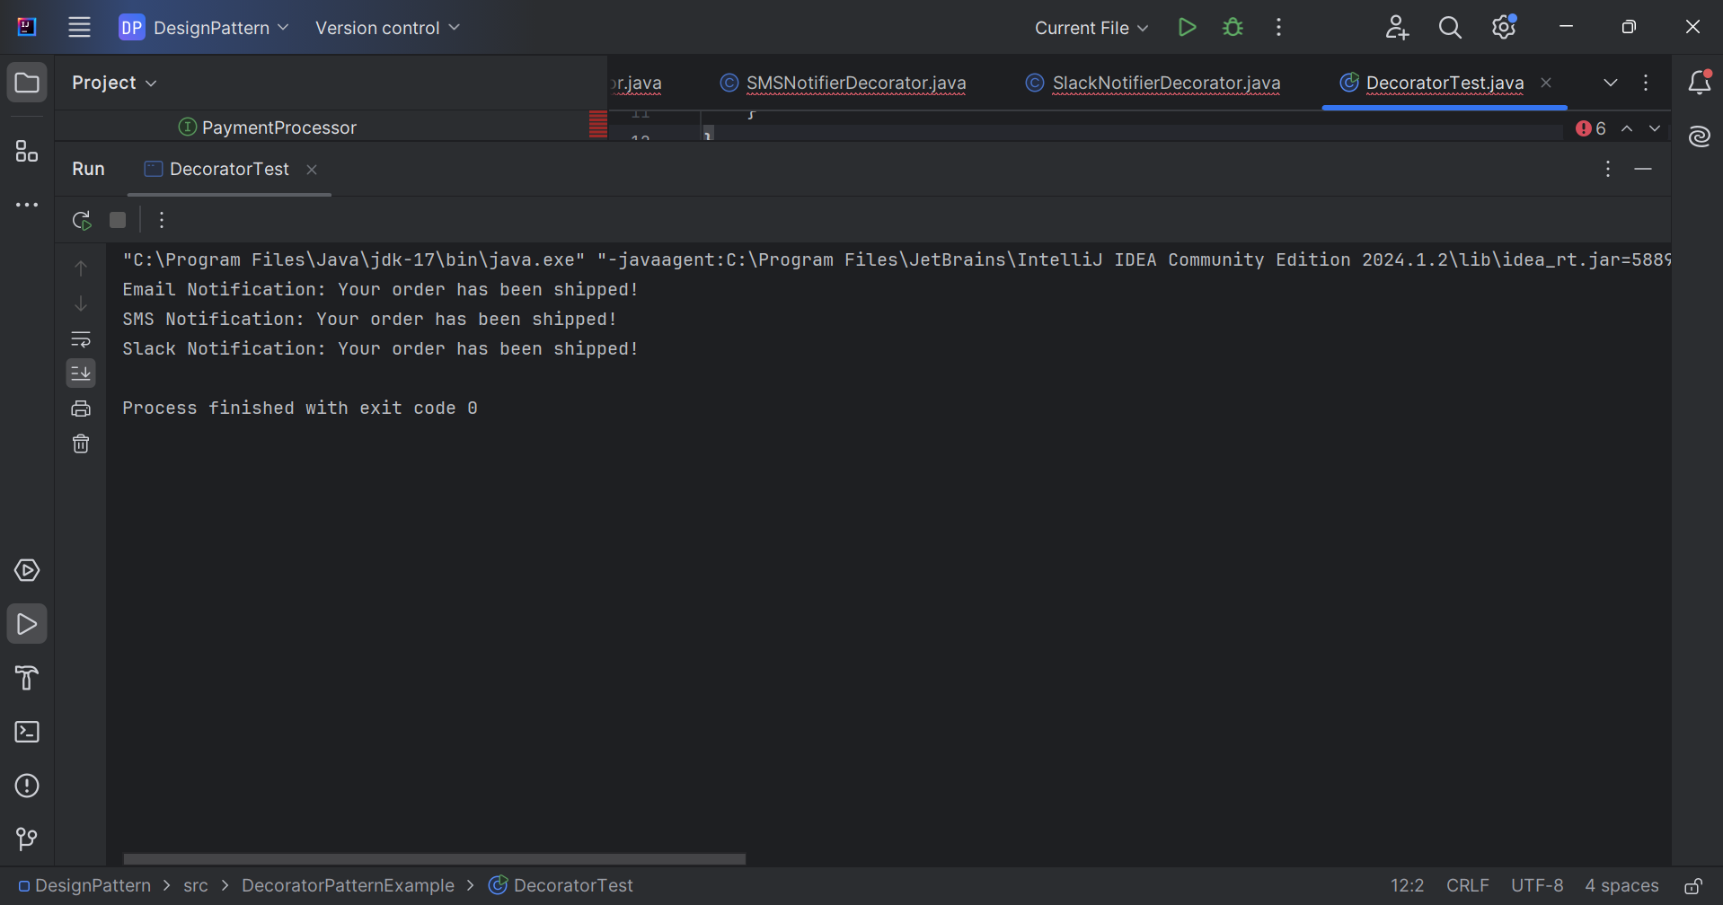
6.Implementing the Proxy Pattern
Image.java
public interface Image {
void display();
}
RealImage.java
public class RealImage implements Image {

private String fileName;

public RealImage(String fileName) {
this.fileName = fileName;
loadFromServer();
}

private void loadFromServer() {
System.out.println("Loading image from remote server: " + fileName);
}

@Override
public void display() {
System.out.println("Displaying image: " + fileName);
}
}
ProxyImage.java
public class ProxyImage implements Image {

private RealImage realImage;
private String fileName;

public ProxyImage(String fileName) {
this.fileName = fileName;
}

@Override
public void display() {

if (realImage == null) {
realImage = new RealImage(fileName);
}

realImage.display();
}
}
ProxyTest.java
public class ProxyTest {

public static void main(String[] args) {

Image image = new ProxyImage("nature.jpg");

System.out.println("Image object created.");

System.out.println("\nFirst Display:");
image.display();

System.out.println("\nSecond Display:");
image.display();
}
}
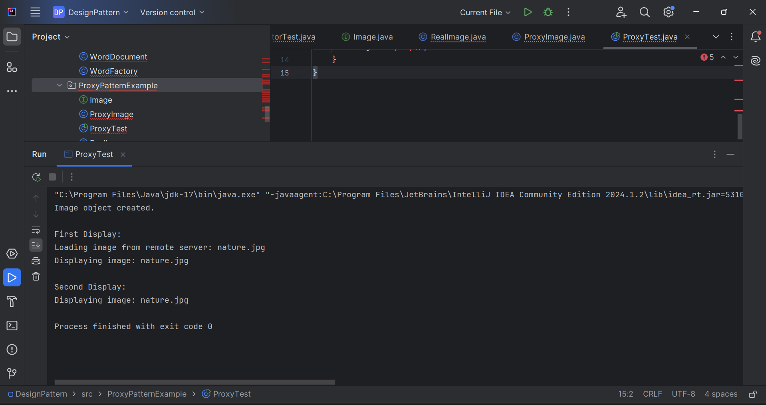
7.Implementing the Observer Pattern
Stock.java

public interface Stock {

void registerObserver(Observer observer);

void removeObserver(Observer observer);

void notifyObservers();
}
StockMarket.java
import java.util.ArrayList;
import java.util.List;

public class StockMarket implements Stock {

private List<Observer> observers = new ArrayList<>();

private String stockName;
private double price;

@Override
public void registerObserver(Observer observer) {
observers.add(observer);
}

@Override
public void removeObserver(Observer observer) {
observers.remove(observer);
}

@Override
public void notifyObservers() {

for (Observer observer : observers) {
observer.update(stockName, price);
}
}

public void setStockData(String stockName, double price) {
this.stockName = stockName;
this.price = price;

System.out.println("\nStock Updated:");
System.out.println(stockName + " = Rs." + price);

notifyObservers();
}
}
MobileApp.java
public class MobileApp implements Observer {

private String user;

public MobileApp(String user) {
this.user = user;
}

@Override
public void update(String stockName, double price) {
System.out.println(
"Mobile App [" + user + "] Notification: "
+ stockName + " price is Rs." + price);
}
}
WebApp.java
public class WebApp implements Observer {

private String user;

public WebApp(String user) {
this.user = user;
}

@Override
public void update(String stockName, double price) {
System.out.println(
"Web App [" + user + "] Notification: "
+ stockName + " price is Rs." + price);
}
}
ObserverTest.java
public class ObserverTest {

public static void main(String[] args) {

StockMarket stockMarket = new StockMarket();

Observer mobileUser =
new MobileApp("Bhavana");

Observer webUser =
new WebApp("Rahul");

stockMarket.registerObserver(mobileUser);
stockMarket.registerObserver(webUser);

stockMarket.setStockData("TCS", 4200.50);

stockMarket.setStockData("Infosys", 1650.75);
}
}
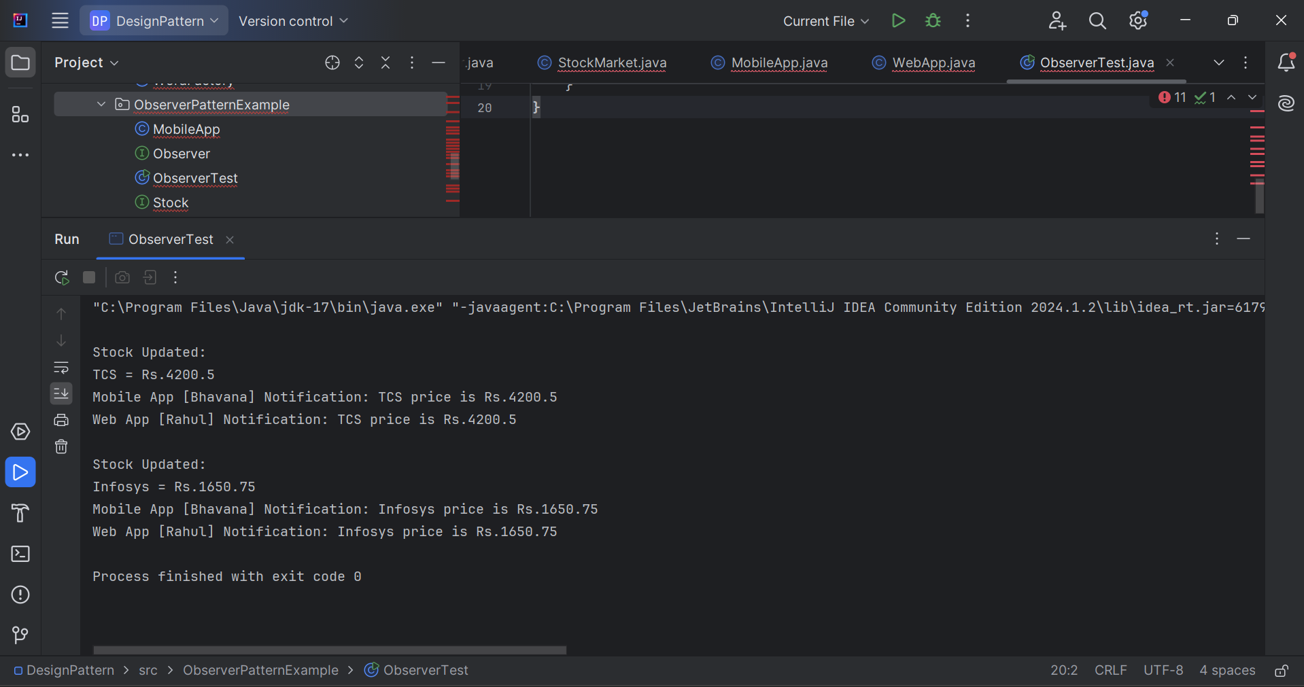

8.Implementing the Strategy Pattern
PaymentStrategy.java
public interface PaymentStrategy {

void pay(double amount);
}
CreditCardPayment.java
public class CreditCardPayment implements PaymentStrategy {

private String cardNumber;

public CreditCardPayment(String cardNumber) {
this.cardNumber = cardNumber;
}

@Override
public void pay(double amount) {
System.out.println("Paid Rs." + amount +
" using Credit Card: " + cardNumber);
}
}
PayPalPayment.java
public class PayPalPayment implements PaymentStrategy {

private String email;

public PayPalPayment(String email) {
this.email = email;
}

@Override
public void pay(double amount) {
System.out.println("Paid Rs." + amount +
" using PayPal Account: " + email);
}
}
PaymentContext.java
public class PaymentContext {

private PaymentStrategy paymentStrategy;

public void setPaymentStrategy(PaymentStrategy paymentStrategy) {
this.paymentStrategy = paymentStrategy;
}

public void executePayment(double amount) {
paymentStrategy.pay(amount);
}
}
StrategyTest.java
public class StrategyTest {

public static void main(String[] args) {

PaymentContext context = new PaymentContext();

// Credit Card Payment
context.setPaymentStrategy(
new CreditCardPayment("1234-5678-9012"));

context.executePayment(5000);

// PayPal Payment
context.setPaymentStrategy(
new PayPalPayment("user@gmail.com"));

context.executePayment(2500);
}
}
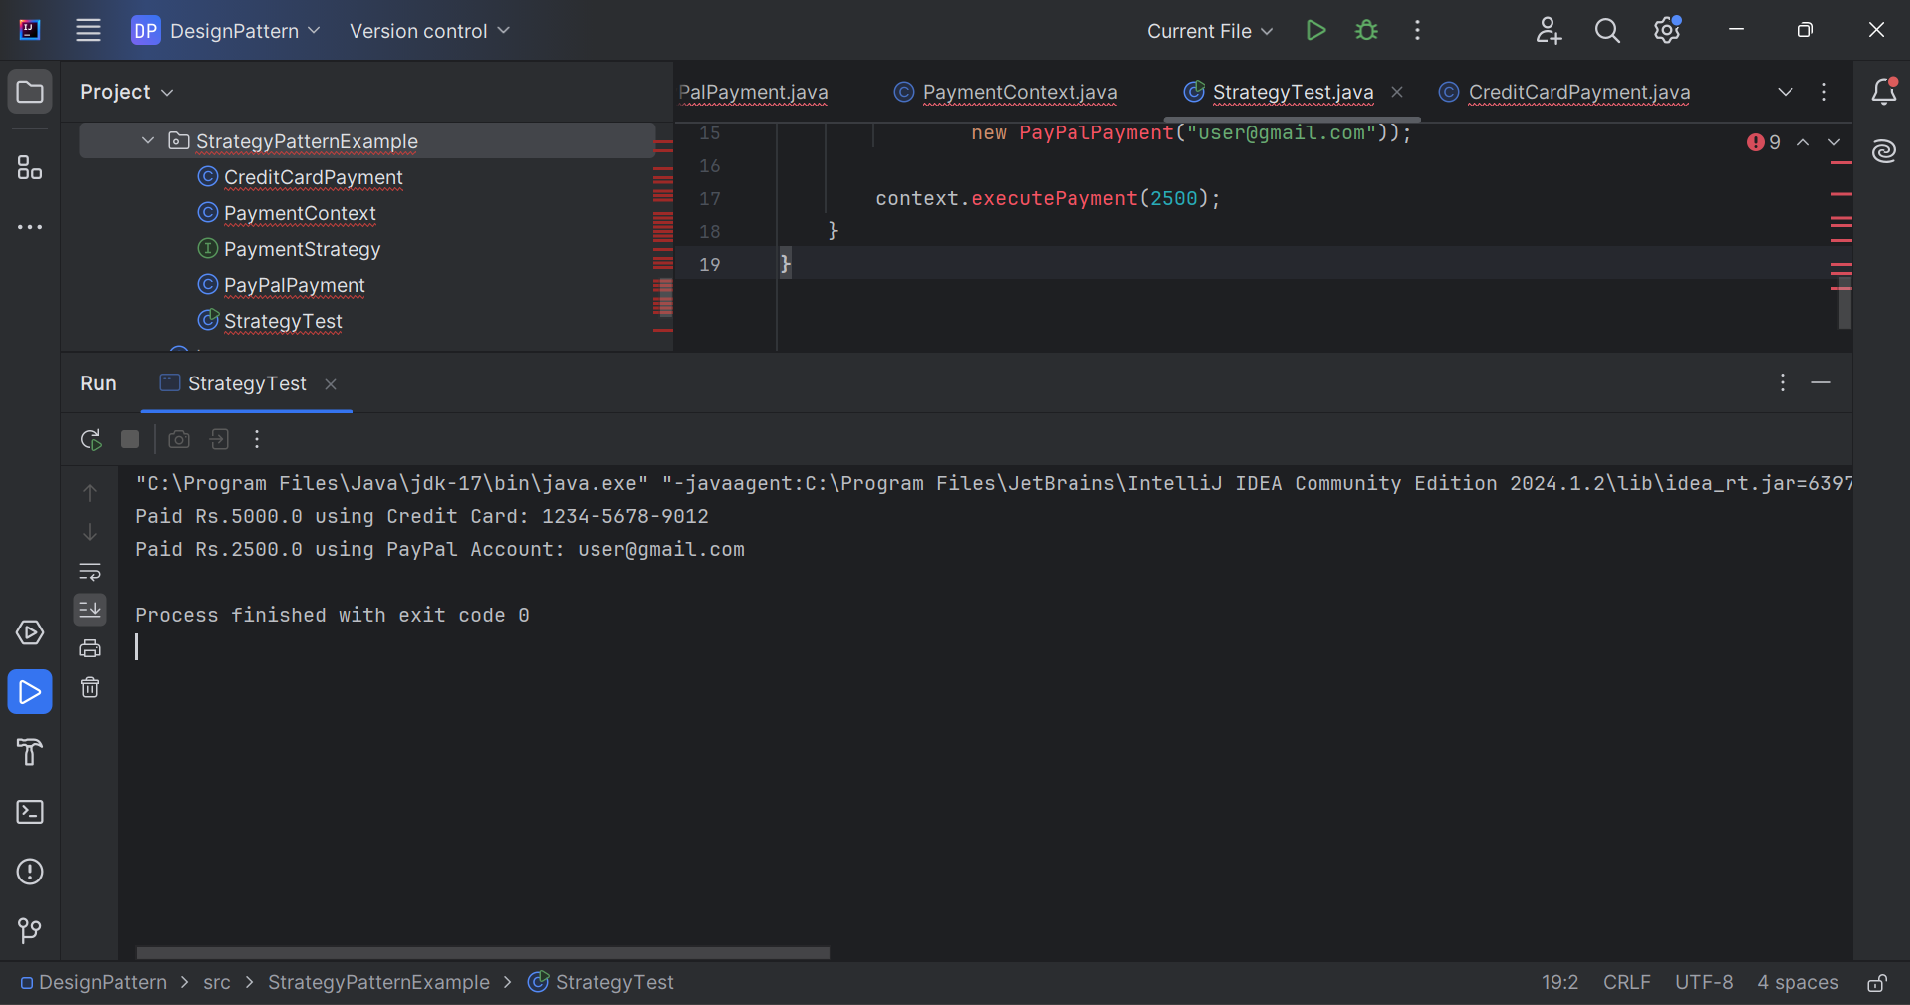
9.Implementing the Command Pattern
Command.java
public interface Command {
void execute();
}
Light.java
public class Light {

public void turnOn() {
System.out.println("Light is ON");
}

public void turnOff() {
System.out.println("Light is OFF");
}
}
LightOnCommand.java
public class LightOnCommand implements Command {

private Light light;

public LightOnCommand(Light light) {
this.light = light;
}

@Override
public void execute() {
light.turnOn();
}
}
LightOffCommand.java
public class LightOffCommand implements Command {

private Light light;

public LightOffCommand(Light light) {
this.light = light;
}

@Override
public void execute() {
light.turnOff();
}
}
RemoteControl.java
public class RemoteControl {

private Command command;

public void setCommand(Command command) {
this.command = command;
}

public void pressButton() {
command.execute();
}
}
CommandTest.java
public class CommandTest {

public static void main(String[] args) {

Light light = new Light();

Command lightOn = new LightOnCommand(light);
Command lightOff = new LightOffCommand(light);

RemoteControl remote = new RemoteControl();

remote.setCommand(lightOn);
remote.pressButton();

remote.setCommand(lightOff);
remote.pressButton();
}
}
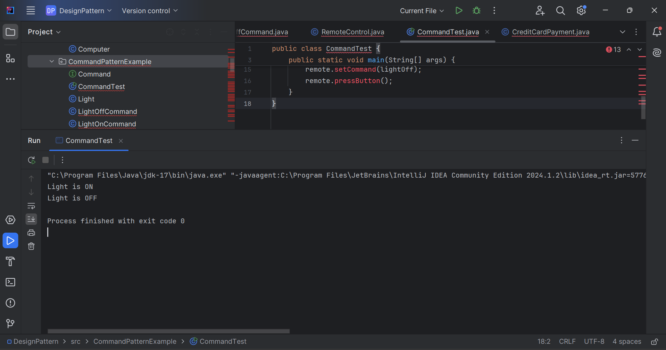
10.Implementing the MVC Pattern
Student.java
public class Student {

private String name;
private int id;
private String grade;

public Student(String name, int id, String grade) {
this.name = name;
this.id = id;
this.grade = grade;
}

// Getters and Setters
public String getName() {
return name;
}

public void setName(String name) {
this.name = name;
}

public int getId() {
return id;

}

public void setId(int id) {
this.id = id;
}

public String getGrade() {
return grade;
}

public void setGrade(String grade) {
this.grade = grade;
}
}
StudentView.java
public class StudentView {

public void displayStudentDetails(
String name,
int id,
String grade) {

System.out.println("Student Details");
System.out.println("Name : " + name);
System.out.println("ID : " + id);
System.out.println("Grade : " + grade);
}
}
StudentController.java
public class StudentController {

private Student model;
private StudentView view;

public StudentController(Student model,
StudentView view) {

this.model = model;
this.view = view;
}

public void setStudentName(String name) {
model.setName(name);
}

public String getStudentName() {
return model.getName();
}

public void setStudentGrade(String grade) {
model.setGrade(grade);
}

public String getStudentGrade() {
return model.getGrade();
}

public void updateView() {
view.displayStudentDetails(
model.getName(),
model.getId(),
model.getGrade());
}
}
MVCTest.java
public class MVCTest {

public static void main(String[] args) {

// Create Model
Student student =
new Student("Bhavana", 101, "A");

// Create View
StudentView view = new StudentView();

// Create Controller
StudentController controller =
new StudentController(student, view);

System.out.println("Initial Student Details:");
controller.updateView();

// Update Student Data
controller.setStudentName("Suba");
controller.setStudentGrade("A+");

System.out.println("\nUpdated Student Details:");
controller.updateView();
}
}
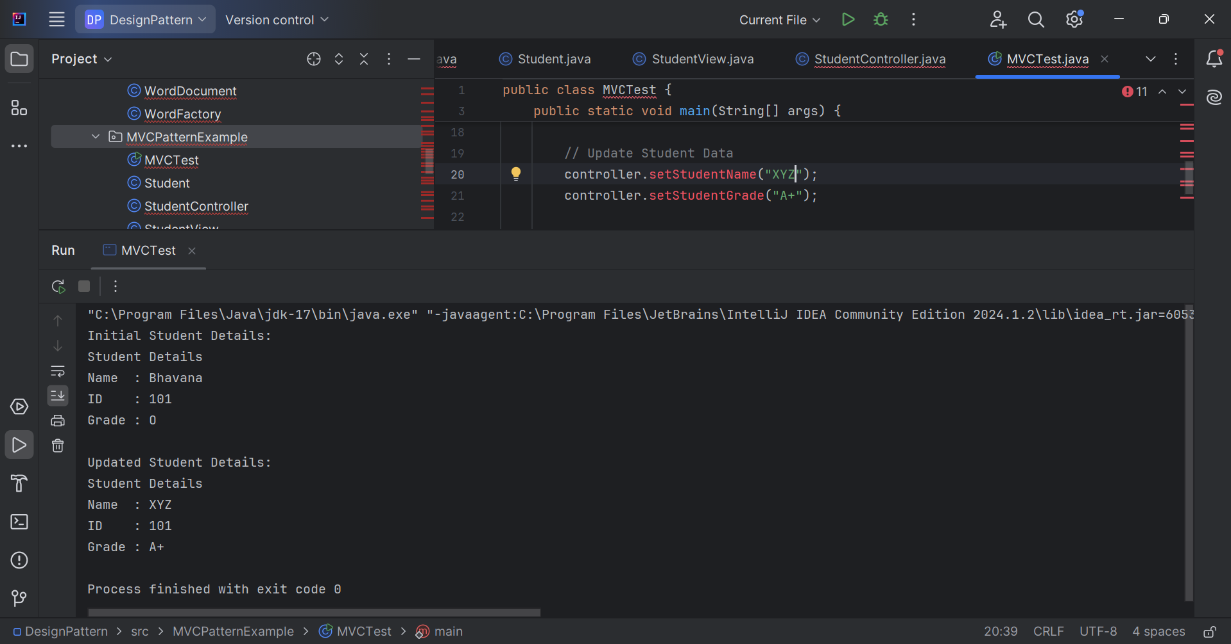
11.Implementing Dependency Injection
CustomerRepository.java
public interface CustomerRepository {

String findCustomerById(int id);
}
CustomerRepositoryImpl.java
public class CustomerRepositoryImpl implements CustomerRepository {

@Override
public String findCustomerById(int id) {

if (id == 101) {
return "Bhavana";
}

return "Customer Not Found";
}
}
CustomerService.java
public class CustomerService {

private CustomerRepository repository;

// Constructor Injection
public CustomerService(CustomerRepository repository) {
this.repository = repository;
}

public void getCustomerDetails(int id) {

String customer = repository.findCustomerById(id);

System.out.println("Customer ID: " + id);
System.out.println("Customer Name: " + customer);
}
}
DependencyInjectionTest.java
public class DependencyInjectionTest {

public static void main(String[] args) {

// Dependency Creation
CustomerRepository repository =
new CustomerRepositoryImpl();

// Dependency Injection
CustomerService service =
new CustomerService(repository);

service.getCustomerDetails(101);
}
}
